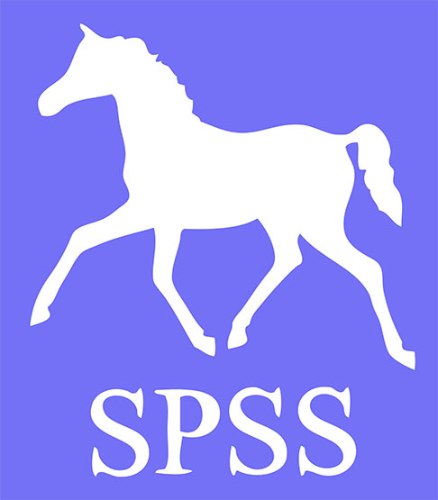
Sports Pony Studbook Society
MEMBERSHIP RENEWAL FORM 2025
Please complete ALL sections of the form below and return it to: SPSS Studbook Office
The Last House
Keysoe Row West
Keysoe
Bedfordshire MK44 2JJ

Please tick as applicable:
Annual Individual Membership: £30
Annual Family or Foreign Membership: £40
Life Membership (Individual): £250
Life Membership (Family): £350
British Breeder Magazine: Free
Note that we are reliant on British Breeding supplying sufficient printed copies of their magazine in order to post to all our members – if we do not get enough copies, we will send on request.

Total payment enclosed/transferred:

Name(s):
Title(s): Mr/Mrs/Miss/Ms/
Address:

Telephone / Mobile numbers:
E-mail address:
Note that by providing an email address you are giving your agreement to receiving occasional information from the SPSS including Newsletters, Notice of Annual General Meetings etc.
I/We agree to abide by the Sports Pony Studbook Society Rules and Regulations

Signed: Date:
(Individual membership is for those aged 18 and over only; those under 18 can be family members but the first listed family member must be 18 or over)
Cheques should be made payable to Sports Pony Studbook Society or pay by bank transfer (see page 2).
Only fully paid-up members of the Sports Pony Studbook Society (SPSS) may register and grade ponies or stand stallions with the SPSS. Annual membership fees are due on 1st January each year.

To pay by one off Bank Transfer, please transfer the amount due (if possible use your name as reference) before returning this form and complete the section below:

Bank: Barclays
Branch: Worthing
Account Holder: The Sports Pony Studbook Society
Sort Code: 20-98-74
Account: 20439428

Amount transferred:
Date of transfer:
Account Holder:
Reference used:

If paying by bank transfer then this form may be scanned/photographed and returned by email provided it has been signed on page 1.

